
Manitoba Conservation
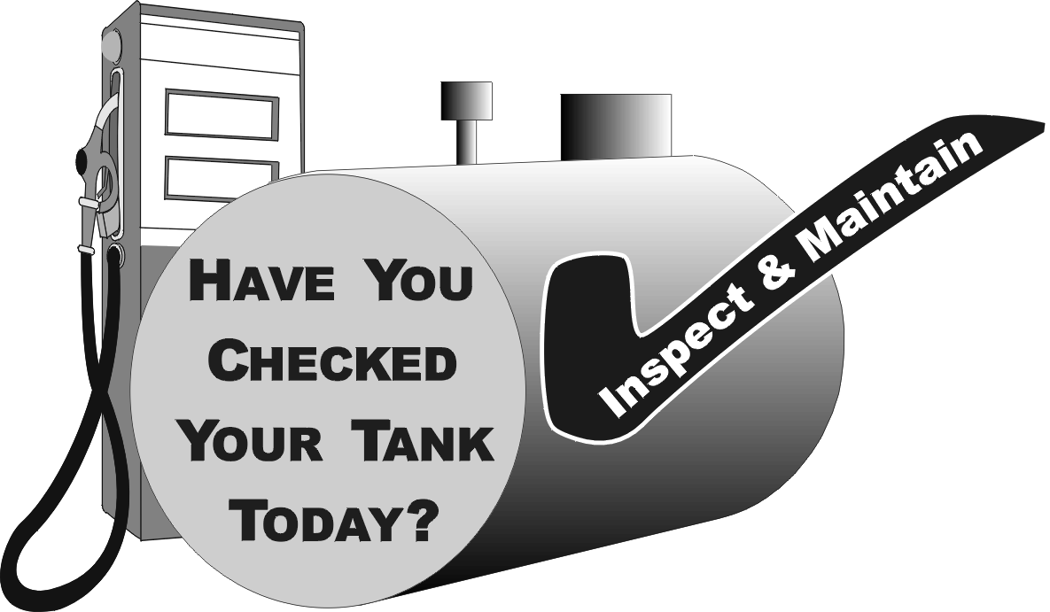

Storage and Handling of Petroleum Products & Allied Products Regulation (M.R. 188/2001)

Only petroleum storage tanks* that have been registered with Manitoba Conservation can be operated. All petroleum storage tank installations and alternations must be registered with Manitoba Conservation prior to the start of a project.

- All new tank installations must meet design and installation standards as set out in the Regulation under The Dangerous Goods Handling and Transportation Act. New tank installations must be tested before they are set into operation.
- Daily inventory balance records on an approved form must be maintained for underground petroleum storage tanks, for each day of operation.
- Weekly inventory balance records on an approved form must be maintained for aboveground vertical tanks or any aboveground tank (vertical or horizontal) having underground piping.
- Confirmed leaks from a storage tank system, and any petroleum spill of 100 litres or more must be reported immediately. Manitoba Conservation’s 24-hour emergency reporting number is 204-945-4888.
- Any underground or aboveground tank which has been out of service for a period of 12 months or more, is considered abandoned and must be removed and disposed of in a proper manner. Underground tanks may be filled with inert material, subject to conditions set out by Manitoba Conservation.
- Manitoba Conservation can issue Orders to the owner(s) or operator(s) of a petroleum storage tank or the present or previous owner of the property, to determine the nature and extent of any contamination which may have resulted from the operation of the storage tank system, and to conduct site remediation.
- Persons convicted of violating any of the above items are subject to fines up to $100,000 and/or 1 year imprisonment. Corporations convicted of violating any of the above are subject to fines up to $1 million.

*The Dangerous Goods Handling and Transportation Act applies to all underground tanks, regardless of capacity, and to all aboveground tanks with a capacity of 5000 litres (1100 gal.) or more, with the exception of Section 9 of the Regulation (see below), which also governs smaller aboveground tanks in certain locations.

Although smaller aboveground tanks are not normally covered by environmental legislation, Manitoba Conservation is informing all lodges and outfitters with facilities used for hunting, fishing or ecotourism, that they will have to comply with Section 9.

Section 9 applies to aboveground petroleum storage tanks in areas of special sensitivity, which are areas where a release of petroleum (or allied product) could create a risk to surface or ground-water quality, or to public health or safety. This applies to all tanks adjacent to waterbodies. Consequently, all aboveground tanks over 230 litres capacity must have a secondary containment. Secondary containment can be a double- wall tank or a dike and dike area that will contain all of the fluid released from a leak or spill, so that none of it flows, leaks, or leaches into the soil or water. All operators should ensure that all petroleum products and other hazardous materials are stored in a manner that minimizes possibility of accidental release into the environment. Aboveground storage tanks of more than 230 litres are also regulated under the Fire Code.

For further information contact: Maurice Mazerolle, Co-ordinator
Manitoba Conservation

123 Main St., Suite 160, Winnipeg, MB R3C 1A5
Telephone 204-945-7110, Fax 204-948-2420
E-mail: mmazerolle@gov.mb.ca
or contact your local Environment Officer

